Vapor Phase Reflow’s Effect on Solder Paste Residue Surface Insulation Resistance

Karen Tellefsen. Mitch Holtzer, Corne Hoppenbrouwers
Alpha Assembly Solutions
South Plainfield, NJ, USA
Roald Gontrum
SmartTech
Rodgau, Germany

Abstract
Surface insulation resistance (SIR) is a critical material property for electrically reliable assemblies using no-clean SMT assemblies. It has been shown in recent studies that the reflow profile and atmosphere used can have significant effects on the SIR properties of no-clean solder paste. In this study, multiple reflow profiles were used in a vapor phase reflow process.(1)
Vapor phase reflow is the process of subjecting an assembly with unreflowed solder paste and components to a temperature equal to the boiling point of the liquid used in the reflow process. This type of process offers several advantages, especially for assemblies with a large amount of thermal inertia. Differences in temperature at different locations on the board can be reduced. In addition, lower peak temperatures can be used versus a typical reflow profile in a convection reflow oven. This can reduce the thermal stress on smaller components that otherwise could reach higher temperatures in a conventional convection oven process.
Another advantage is that the reflow liquid vapor is extremely inert, reducing any potential for excessive oxidation which can increase the incidence of head in pillow defects. It is well known that an inert atmosphere also increases the spread and wetting of lead free alloys. This also contributes to the reduction in voiding under bottom terminated components.

INTRODUCTION
Vapor phase reflow has created a niche in the surface mount technology (SMT) industry for several fundamental reasons. Assemblies with large themal mass that contain small discrete components are excellent candidates for vapor phase reflow.
In this reflow process, a populated circuit board is preheated using one of several methods, then immersed in a chamber containing evaporated solvent with a boiling point sufficient to reflow solder paste, and create intermetallic compounds with component Ios and metallic pads on the printed circuit board.
In theory, the maximum temperature of the solder paste, components and board is limited to the boiling point of the vapor phase solvent that is used. Some have argued that the boiling point could rise or fall if the vapor phase fluid is contaminated. Also, the boiling of the vapor phase solvent is dependant on altitude. At higher altitudes, the boiling point decreases.
In order to reduce the thermal shock of an assembly being imersed in a 230°C chamber, preheating is generally recommended. This can be done with an in-line IR heater, or by managing the time and distance that the assembly spends above the vapor phase chamber. Figure 1-

Figure 1- Vapor Phase Reflow Process Principle

Both types of preheating were used in this study.
One issue is that if an assembly has regions where the temperature is below the boiling point of the solvent, the solvent will percipitate onto the colder regions. The fluid will evaporate as soon as it reaches the boiling point again This raises the issue of interaction with unreflowed solder paste and the vapor phase fluid, and what if any effect does this interaction have on the Surface Insulation Resistance of the final assembly.
The other question that promted this study was the vaporization of weak organic acids, a key to high reliability no clean solder paste. Excessive amounts of weak organic acid in the solder paste flux residue could create an opportunity for dendritic growth, if exposed to moisture and a voltage bias. How is the vaporization of weak organic acids affected if the reflow is carried out in a high vapor pressure environment of solvent, versus the hot, dry conditions associated with a conventional convection oven.

Experimental Procedure
A test vehicle used by SmartTech called the Wuerfel (German for Cube) (Figure 2) was used to evaluate 14 different solder paste combinations consisting of 9 flux types and 3 lead free alloys. Performance criteria for the test included voiding, tomb stoning, wetting, pin in paste Cappability and residue appearance.
Figure 2- Wuerfel Test Vehicle

The test vehicles used all had the same Electroless Nickel, Immersion Gold (ENIG) surface finish. All boards were printed using the same printer and print settings. A single pick and place machine placed the components.
Three reflow systems were used. One was a vapor phase unit with no external preheating. Preheating in this system is accomplished by holding the board at designated heights above the vapor phase chamber. Figure 3

Figure 3- Vapor Phase Reflow Machine –Internal Preheating

The second system used a Infra Red (IR) oven, inerted with nirogen, in line with the vapor phase chamber. Figure 4 shows this machine
.

Figure 4- Vapor Phase Reflow Machine With In-Line IR Preheating

The third reflow method was a conventional convection reflow oven.
The exact outcome of this study would comprimise the non-commercial nature of this paper. However one SAC 305 Type 4 (20-38µdiameter powder) solder paste clearly was superior in the evaluation. This solder paste, along with 3 others that were used in a previous air vs. nitrogen SIR study (3) were evaluated for surface insulation resistance.
The SIR study used TM-650 2.6.3.7. IPC B-24 coupons were pre-cleaned before the 4 solder pastes were printed onto them.
KAREN- you could write this portion of the experimental procedure in a nanosecond
Figure 5.
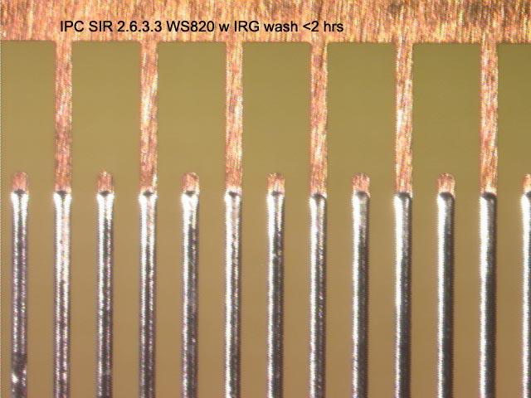
Figure 5- Close Up of Comb Pattern IPC B-24 SIR Test Coupon

REFLOW PROFILES
Because of the vast differences in the configurations of the two vapor phase machines the reflow profiles were not exactly the same. Figures 6 and 7show the profiles used with the the internally heated and in-line inert IR pre-heated vapor phase ovens.
Figure 6- Internally Pre-Heated Vapor Phase Reflow Profile

Figure 7- In Line Inert IR Preheat Vapor Phase Reflow Profile

RESULTS AND DISCUSSION
The results of the SIR testing are depicted in Figure 8. The Y axis is the log of the surface insulation resistance in ohms. The X axis is time. As perscribed by the TM-650 2.6.3.7, the test was conducted for 7 days.
Figure 8- SIR of 4 pastes and Two Vapor Phase Reflow Processes

 | Internal Preheat | In Line Preheat
Paste 1
Paste 2
Paste 3
Paste 4

All four no-clean pastes that were tested in the two vapor phase reflow machines surpassed the requirements of J-STD-004B section 3.4.1.4.1for surface insulation resistance (“All SIR measurements on all test patterns shall exceed the 100 MΩrequirements”) [4].
From this result, the concern that weak organic acids not evaporating because of the vapor pressure of the solvent used, to the extent that TM-650-2.6.3.7 testing would fail, is unwarranted. (Sorry for the German sentence structure!)
Another experiment, comparing the SIR of one paste under three reflow conditions was undertaken. In a previous study, this paste was shown to have an increased level of SIR when reflowed under a nitrogen inerted convection reflow oven versus an air reflow process [3].
Figure 9 shows the results of SIR testing after three different reflow processes. The first two are the vapor phase processes described above, the third was a conventional convection reflow under a nitrogen blanket.

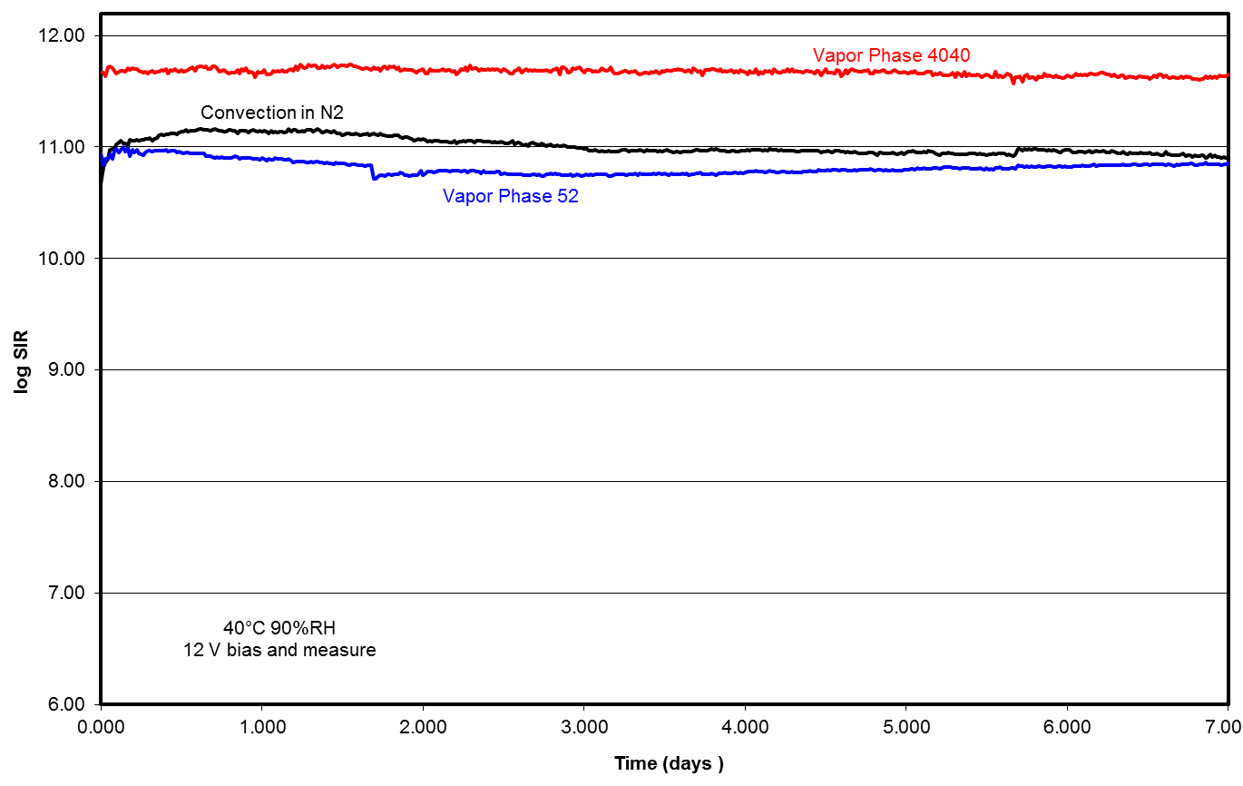
Figure 9- SIR of Paste 1 Under 3 Different Reflow Processes

Another interesting result was that the SIR readings of all 4 pastes appeared to be higher when the internally pre-heated vapor phase reflow machine was used. Figures 10, 11,12 and 13. This could be an effect of the reflow profiles used. This observation would require further confirmation with a reflow profile/SIR design of experiment, but the pattern from this set of experiments seems to be consistant.

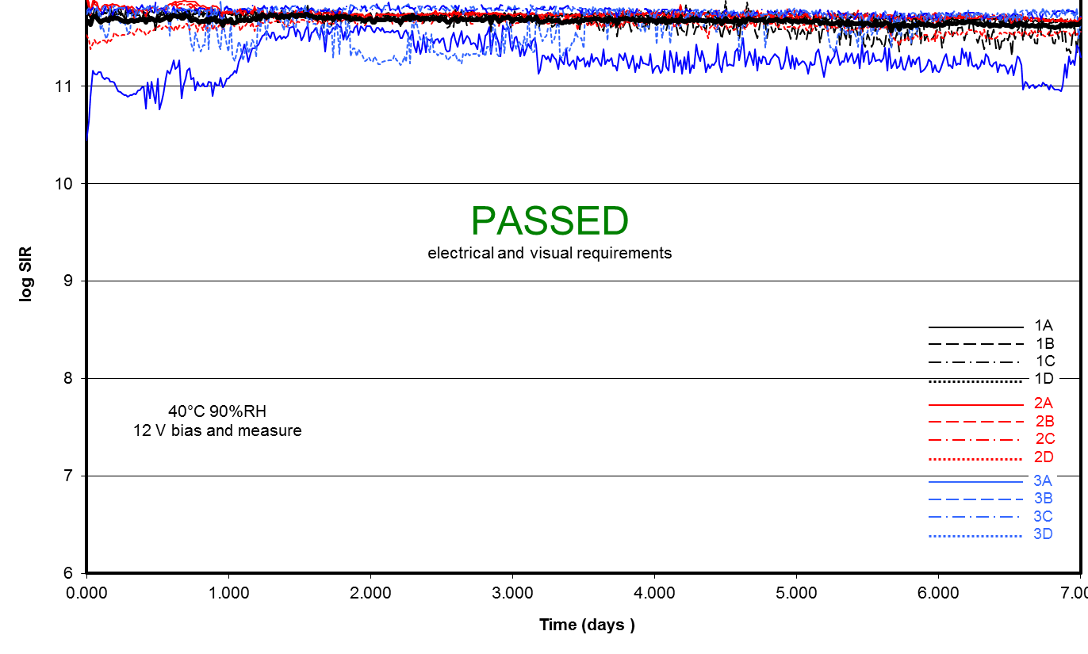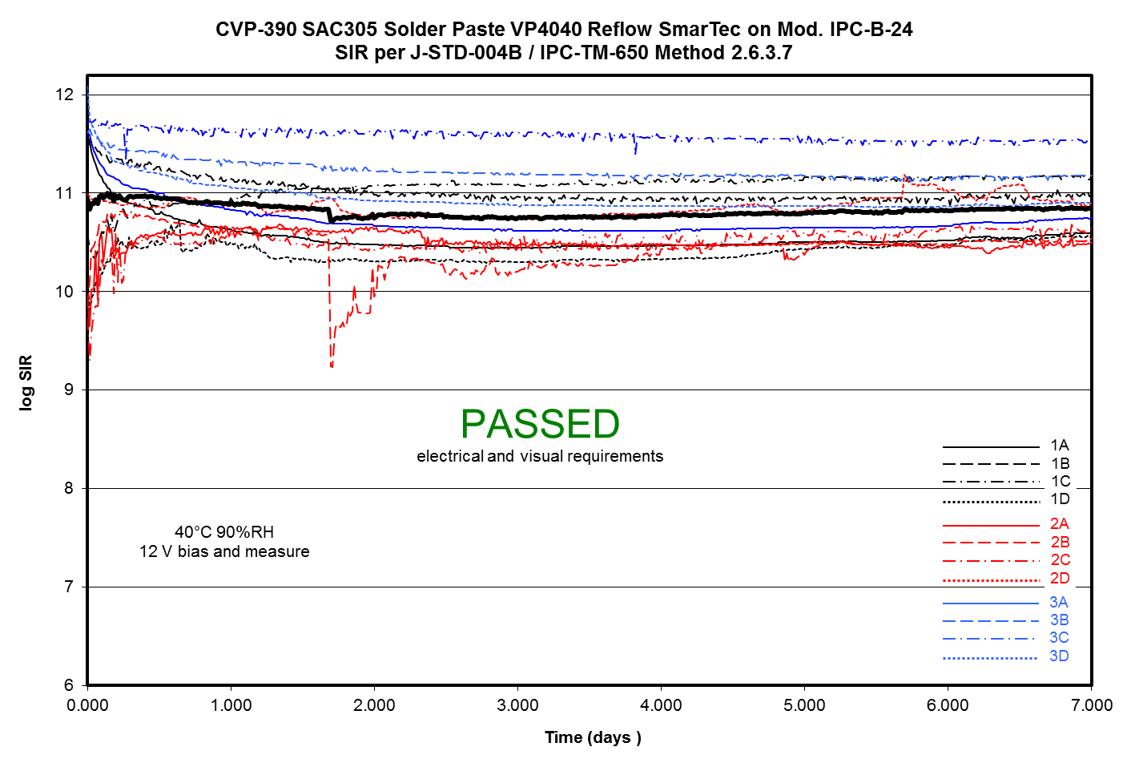
Figure 10- Paste 1 Internal Pre-Heat (Left) and In Line IR Pre-Heat (Right)

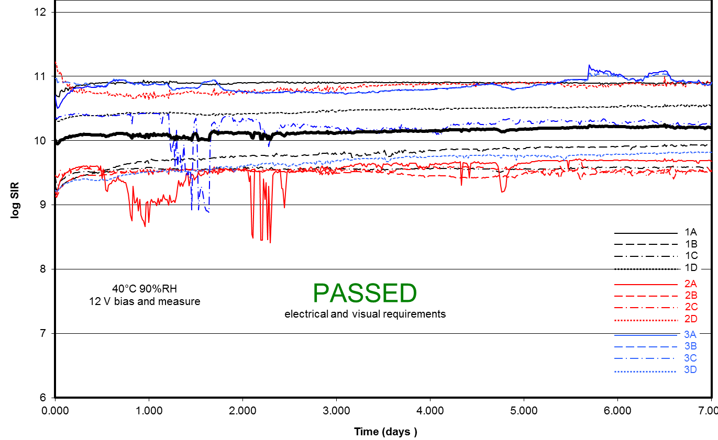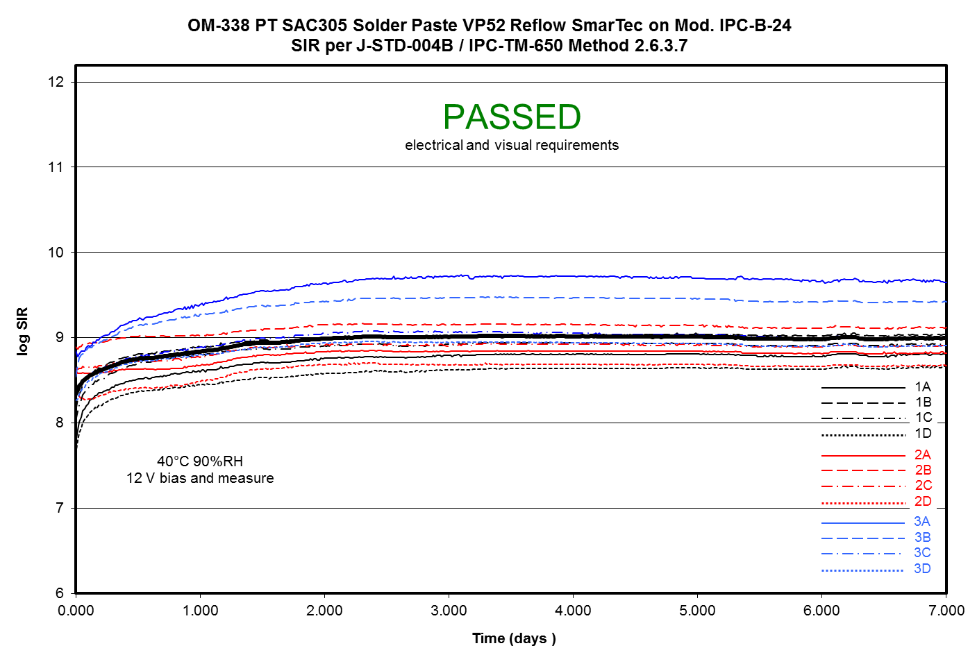
Figure 11- Paste 2 Internal Pre-Heat (Left) and In Line IR Pre-Heat (Right)

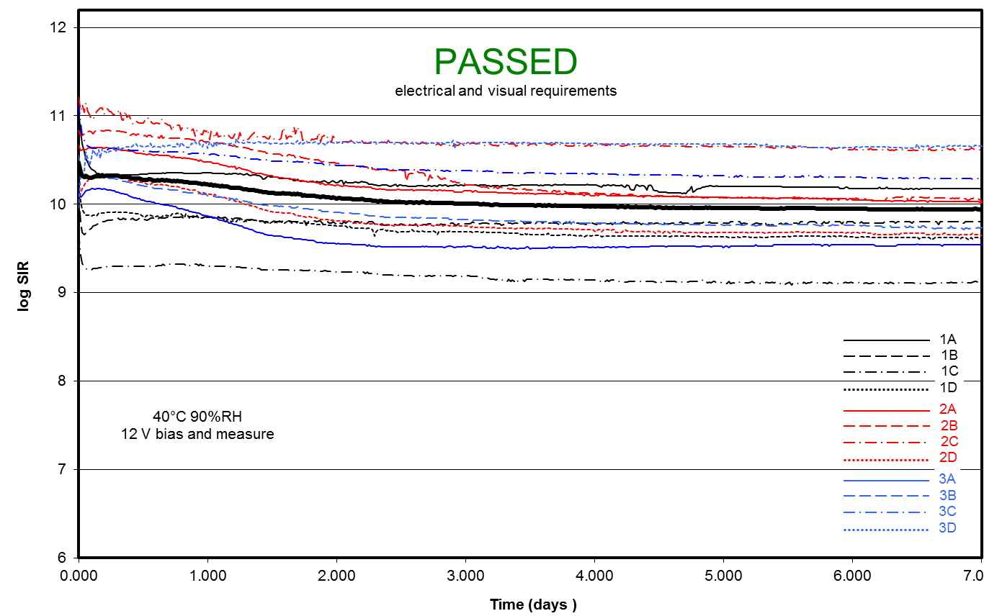
Figure 12- Paste 3 Internal Pre-Heat (Left) and In Line IR Pre-Heat (Right)

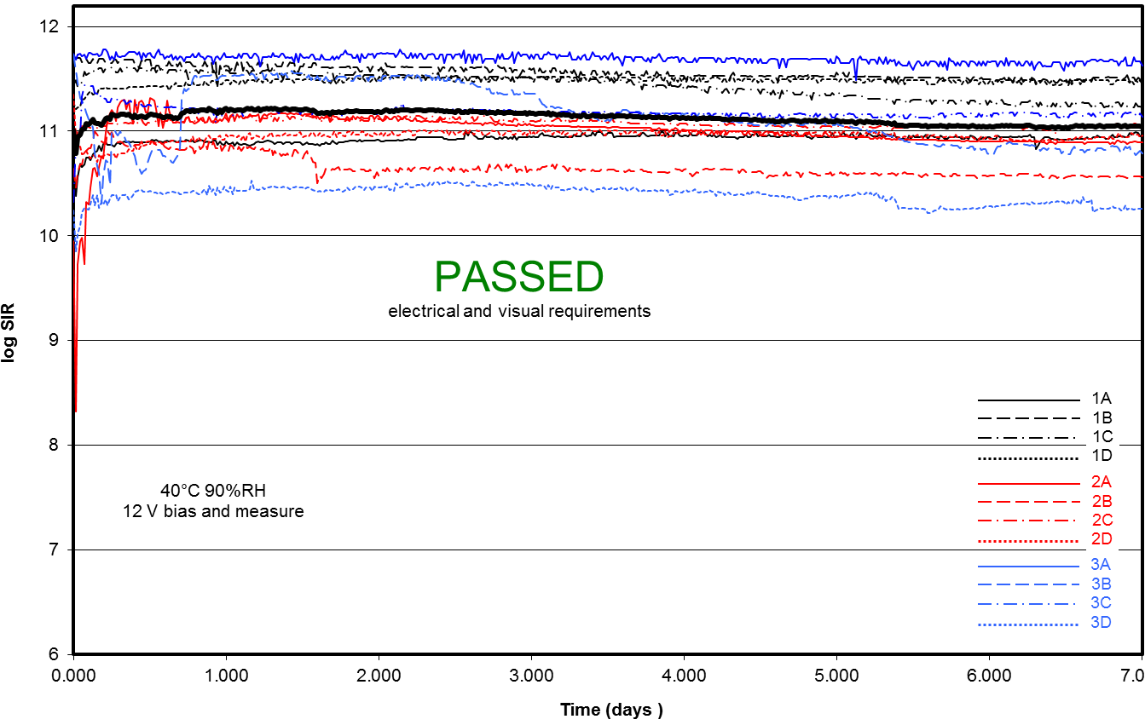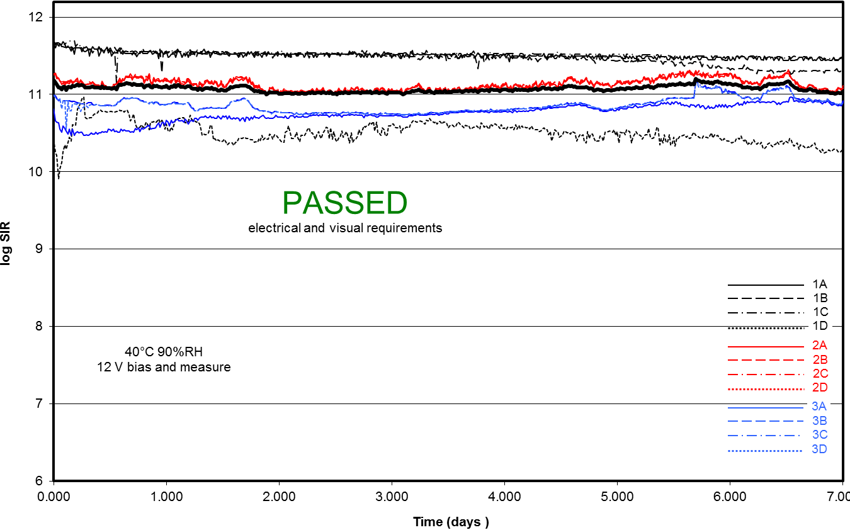
Figure 13- Paste 4 Internal Pre-Heat (Left) and In Line IR Pre-Heat (Right)

CONCLUSIONS
Vapor phase reflow is a

mature process that solves the issue of preserving small discrete components on large thermal mass assemblies. It has shown in this testing, and previously reported work to afford superior wetting to convection oven reflow.
The SIR data also indicates that vapor phase reflow, like nitrogen inertion in convection reflow, increases the SIR results of a no clean solder paste.

References
[1{ Tellefsen
[2] IBM Paper
[3] Tellefsen….
[4] J-STD-004B

